PUBLICATION DATABASE SYSTEM

USER MANUAL

(Group 17)

TABLE OF CONTENT

Introduction ……….................................................................................................................................3

System Operation ……….......................................................................................................................4

Publication Entry……………………………………………………………………………………..…………………….4

Author Entry ……………………………………………………………………………………………………………………5

Publication View ………………………………………………………………………………….…………………………6

Authors and publication Options ………..........................................................................................7-8

Contacts………………………………………………………………………………………………………………………………..………………….…9

INTRODUCTION

Keeping record of publication is essential in the world of academics as it ensures integrity amongst assessment and all other related academic activities. We created a simple database for storing publications that can be viewed and updated. The system requires minimum technical knowledge and its GUI based.

System operation

Add publication – this actions allows the user to add a publication to the database

1. Create new publication

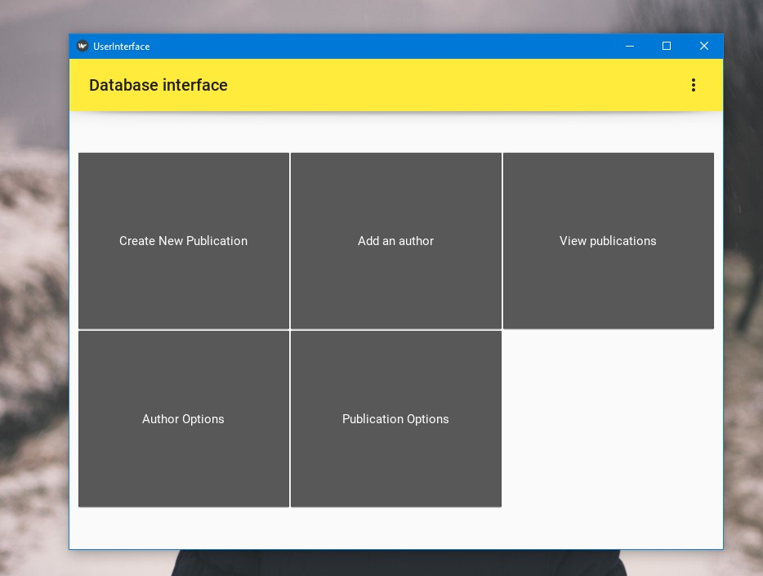

1. Then fill in the details. (2) select type of publication

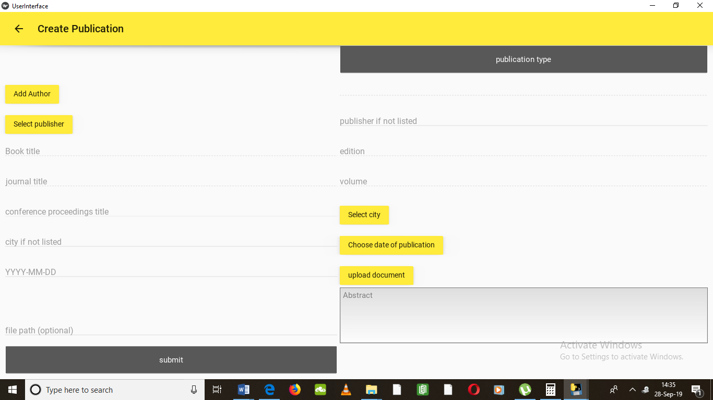

SECTING TYPE OF PUBLICTION

1. Submit to create a new publication



Add author- This actions allows the user to add authors

1. Select add author



1. Than fill in the authors information and submit to add the author

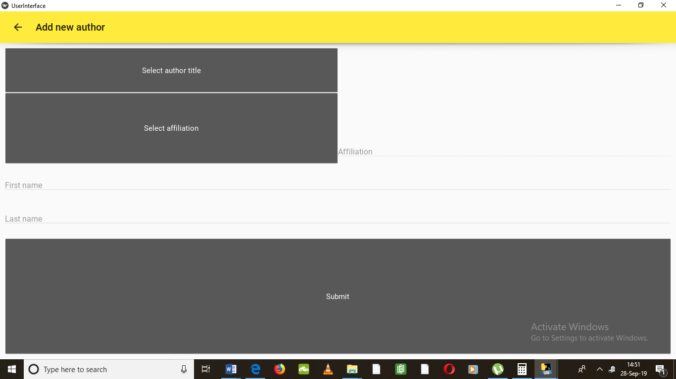

Publication view- This action allows you to view publication

1. Click on publication view this will display all publications



1. The view button allows you to view the publication information

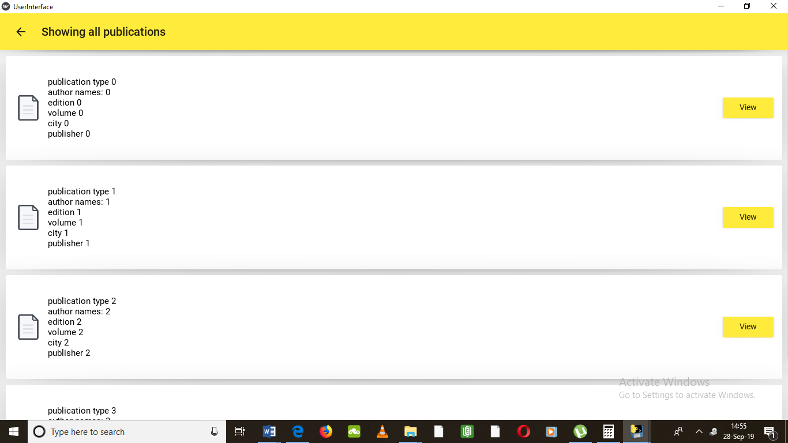

AUTHOR/ PUBLICATION OPTIONS

Add Knew publisher to the System, Add new city to the system, update an existing publisher name, update an existing city name, delete existing city, delete a publisher.

Add new affiliation to the system, Add New Title to the System, Update an Existing Title, Update First and Last Name of Existing Author, Update Name of Existing Affiliation, Delete Affiliation from the System, Delete Author from the System.

1. Click on option



Author options.

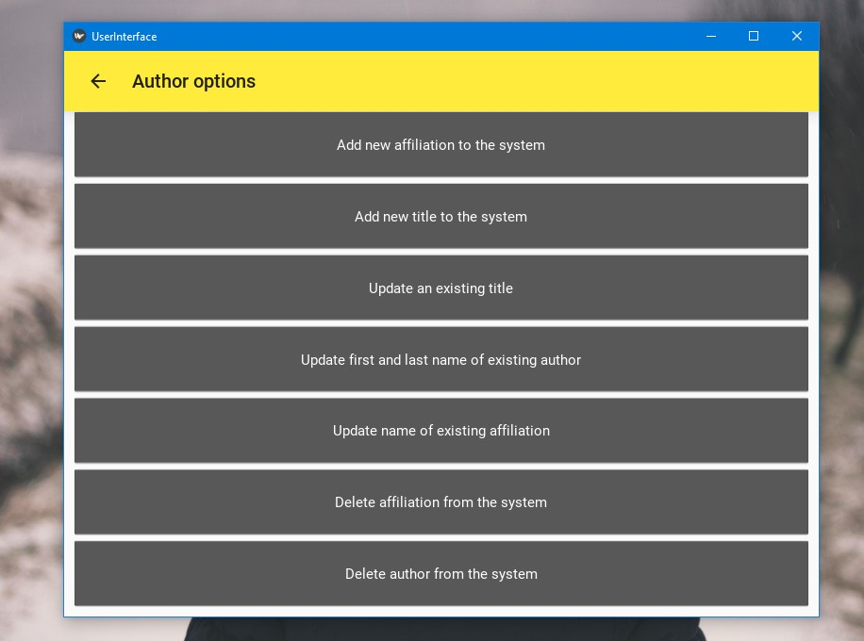

Publication option

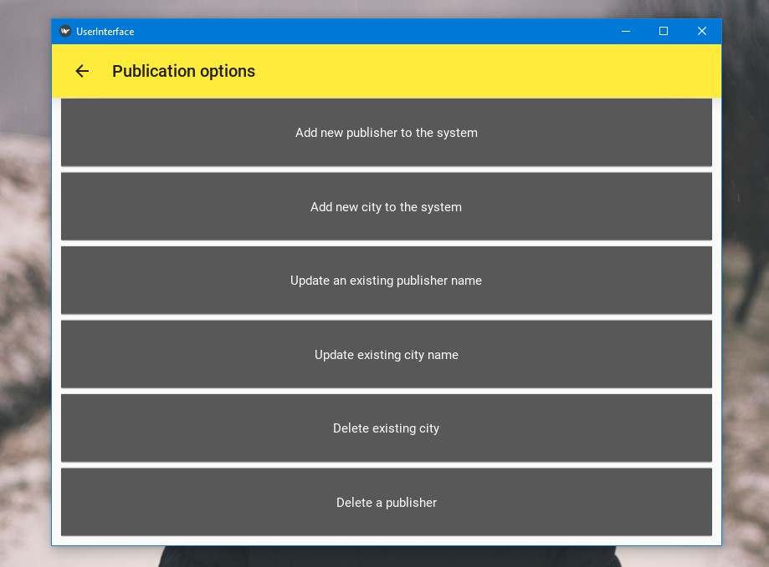

All entries are stored on a database.

Contacts

Thomas David (system technician) speedracer520@gmail.com

Francis Emvula (database technician) francisemv@gmail.com

Stefanus Johannes (customer care) [stefanusjoh@gmail.com](mailto:stefanusjoh@gmail.com)

Litthau made it (General system technician)